

NAME OF THE PROJECT

MALIGNANT COMMENTS CLASSIFICATION

Submitted by:

Ram Kumar

**ACKNOWLEDGMENT**

I have taken efforts in this project. However, it would not have been possible without the kind support and help of many individuals. We would like to extend my sincere thanks to SME. Khushboo Garg .

We are highly indebted to Flip Robo technology for their guidance and constant supervision as well as for providing necessary information regarding the project & also for their support in completing the project.

I thanks and appreciations also go to our colleague in developing the project and people who have willingly helped us out with their abilities.

Thanks all.

Ram kumar

.

**INTRODUCTION**

* The proliferation of social media enables people to express their opinions widely online. However, at the same time, this has resulted in the emergence of conflict and hate, making online ironments uninviting for users. Although researchers have found that hate is a problem across multiple platforms, there is a lack of models for online hate detection.
* Online hate, described as abusive language, aggression, cyberbullying, hatefulness and many others has been identified as a major threat on online social media platforms. Social media platforms are the most prominent grounds for such toxic behaviour.
* There has been a remarkable increase in the cases of cyberbullying and trolls on various social media platforms. Many celebrities and influences are facing backlashes from people and have to come across hateful and offensive comments. This can take a toll on anyone and affect them mentally leading to depression, mental illness, self-hatred and suicidal thoughts.

* Our goal is to build a prototype of online hate and abuse comment classifier which can used to classify hate and offensive comments so that it can be controlled and restricted from spreading hatred and cyberbullying.

**Analytical Problem Framing**

Import library and load the dataset

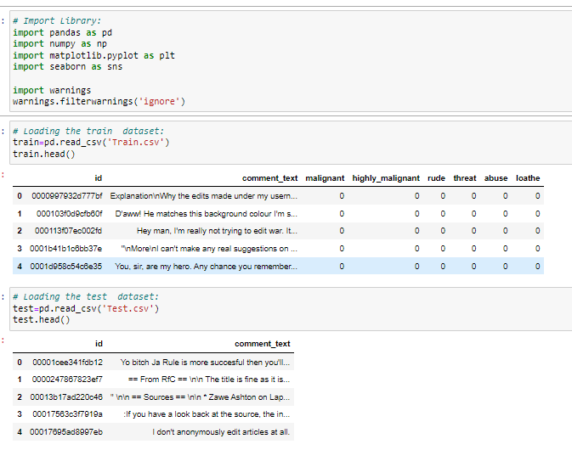

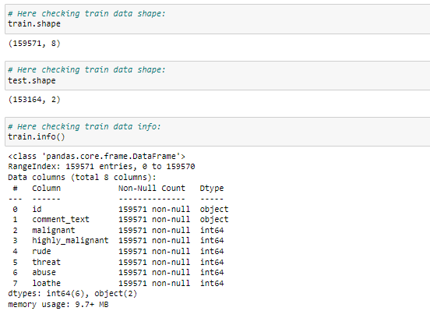

* Display all column name of dataset.

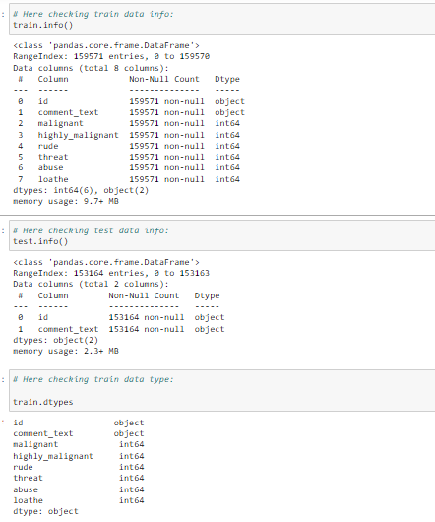

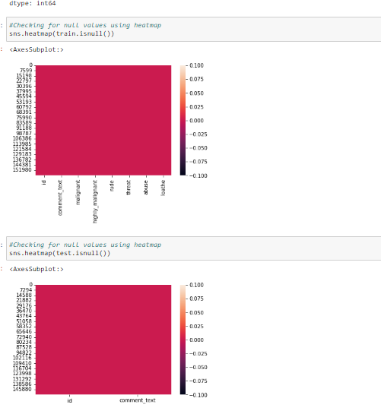

* Display statistical summary.

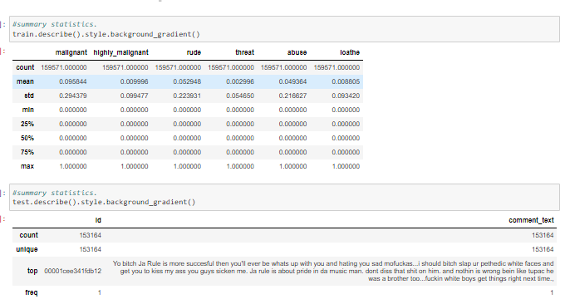

* Display histogram of all columns.

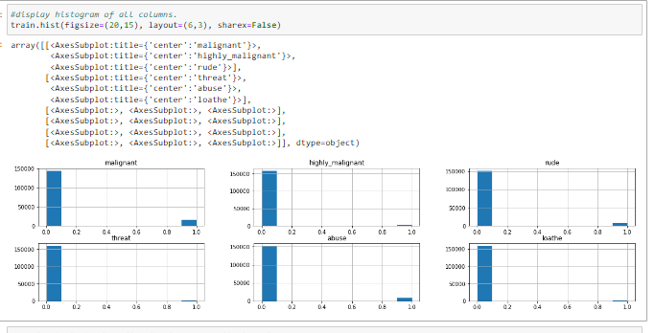

* Display correlation of columns using heatmap.

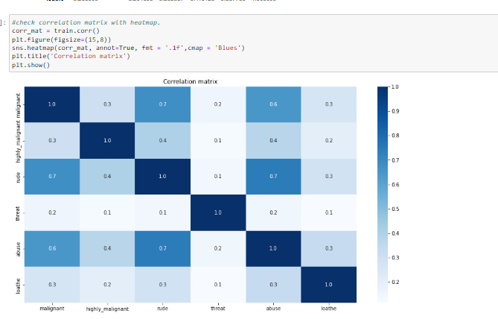

* Display barplot of all columns.

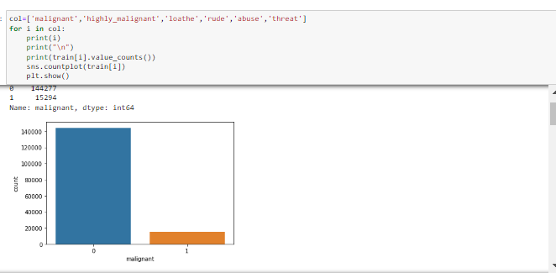

* Display outliers of all columns.

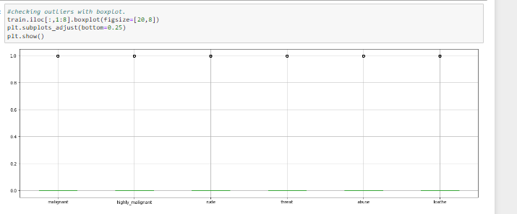

* filling empty values and Replace values. 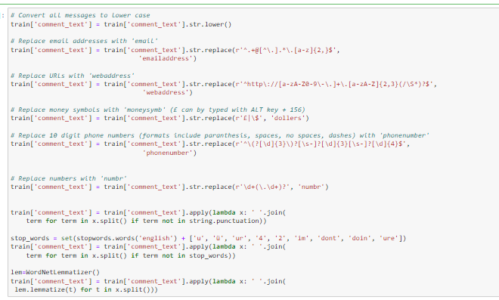
* **Getting sense of loud words which are offensive**

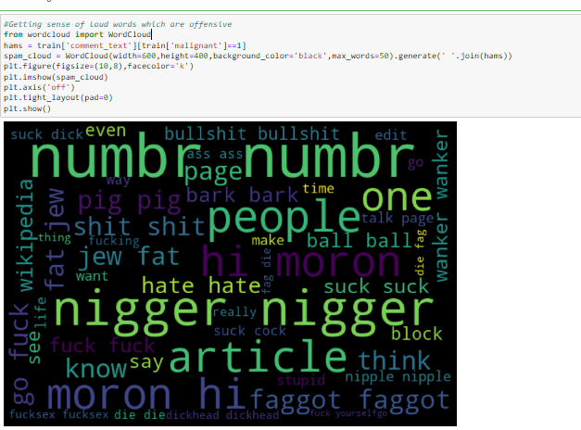

* **Display distribution values:**

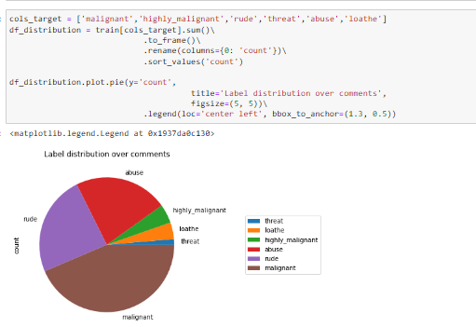

**Model/s Development and Evaluation**

* **Feature engeenering:**

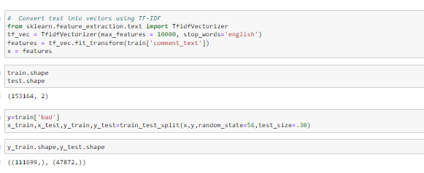

* Testing of Identified Approaches (Algorithms)

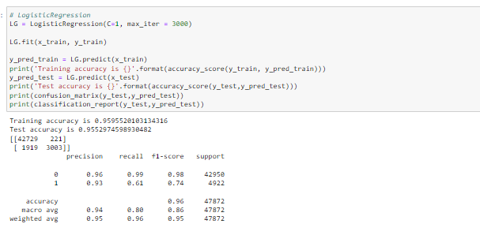

* Run and Evaluate selected models

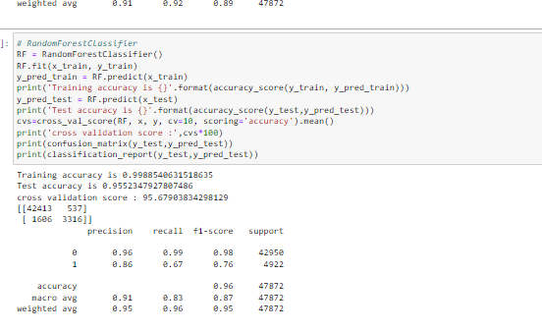

* Creating RMSE:

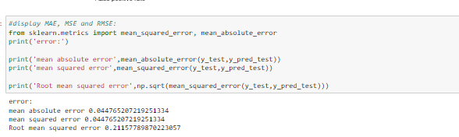

* Decision Tree:

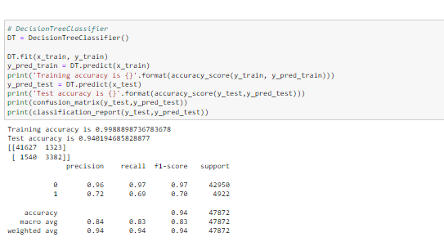

* Interpretation of the Results

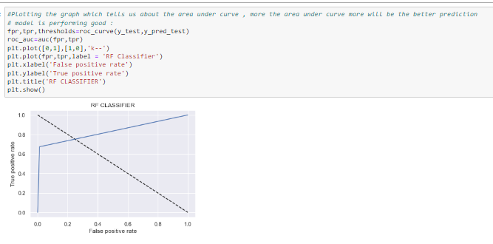

* **Prediction of test dataset:**

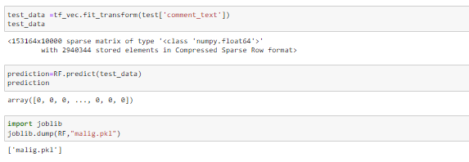

* Hardware and Software Requirements and Tools Used
* **Language :-** Python
* **Tool:-** Jupyter
* **OS:-** Windows 10
* **RAM:-** 8gb

**CONCLUSION**

* The proliferation of social media enables people to express their opinions widely online.
* However, at the same time, this has resulted in the emergence of conflict and hate, making online environments uninviting for users.
* Online hate, described as abusive language, aggression, cyberbullying, hatefulness and many others has been identified as a major threat on online social media platforms.
* This can take a toll on anyone and affect them mentally leading to depression, mental illness, self-hatred and suicidal thoughts.
* Internet comments are bastions of hatred and vitriol.